clear;
clc;
%T is the period
%
T = 4;
%w is the frequency
%
w = (2*pi) / T;
%Compute the complex forier series coeficients
%This result was copied into variable "D" below
%
%Dn = (1/T) * (int(exp(-j*n*w*t), t, 1, 1.5) - .5*int(exp(-j*n*w*t), t, 3, 3.5));
cn = 0;
freq = 0;
t = linspace(0,20,1e5);
xsum = zeros(size(t));
xsum = (1/16);
m = -100;
RC = 10;
H = 0;
for n = 1:200
%D is the result of the Dn integral above
%
%an = (sin((3*pi*n)/2) - sin((7*pi*n)/4))/(2*pi*n) - (sin((pi*n)/2) - sin((3*pi*n)/4))/(pi*n);
%bn = (cos((pi*n)/2) - cos((3*pi*n)/4))/(pi*n) - (cos((3*pi*n)/2) - cos((7*pi*n)/4))/(2*pi*n);
%cn is the complex Fourier coefficients
%
cn(n) = (((sin((pi*m)/2) - sin((3*pi*m)/4))/(pi*m) - (sin((3*pi*m)/2) - sin((7*pi*m)/4))/(2*pi*n))^2 + ((cos((pi*m)/2) - cos((3*pi*m)/4))/(pi*m) - (cos((3*pi*m)/2) - cos((7*pi*m)/4))/(2*pi*m))^2)^(1/2)/2;
%freq stores the frequency in Hz
%
freq(n) = m*(1/T);
H(n) = 1/(j*2*pi*freq(n)*RC + 1);
m = m + 1;
%D = ((exp(-(pi*n*i)/2) - 1)*2*i)/(pi*n);
%xsum = xsum + an.*cos(n.*w.*t) + bn.*sin(n.*w.*t);
end
mag = abs(H);
%subplot(1,2,1);
stem(freq,cn)
legend('Vs');
hold on
title('Vs and H(f) superimposed. RC = 1');
xlabel('freq (Hz)');
ylabel('cn magnitude');
stem(freq,mag)
axis([-25 25 0 .1]);
%
% y = mag .* cn;
% subplot(1,2,2);
% stem(freq,cn)
% hold on
% stem(freq,y)
% axis([-25 25 0 .03]);
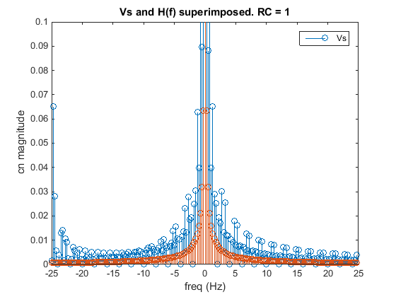
Published with MATLAB® R2014b

